City of Marquette Heights Tree Board
Adopt-A-Tree Program
715 Lincoln Road, Marquette Heights, IL 61554

Dear supporter of Marquette Heights Urban Forest,

Thank you for your interest in the City’s Adopt-A-Tree program. Your support of this program will help to replenish and sustain the City’s Urban Forest.

- To participate: Fill out, sign and submit the enclosed Application/Citizen Tree Maintenance Agreement, agreeing to care for the new tree with payment included. If the request to adopt a tree is to be placed on private property (adopted trees may only be planted within the city only), the Public Works Department will inspect your site to identify which trees, if any, may be best suited for your site. You will be informed as to which species meet the site requirements and planting objectives of the City’s Urban Forestry Plan. Trees adopted for private property will not be planted by City personnel and become the responsibility of the property owner for care and maintenance. If the request to adopt a tree is to be placed on city property the Public Works Department will determine the location to be planted, and which type of tree is best suited for the location.

- To donate a Tree: You may wish to make a donation for the full cost to adopt a tree or trees to be placed on City property. Fill out, sign and submit the enclosed Application/Citizen Tree Maintenance Agreement and enclose your full donation. Full cost, Adopt-A-Tree Program donations are accepted throughout the year.

- Cost: The trees the City purchases and has planted presently cost the City up to $100.00 each. Cost and tree type is dependent on availability. Adopt-A-Tree program participants are requested to contribute 50% of the total cost of each tree they adopt. Applications that are approved will be allowed 1 Adopt-A-Tree program tree and, depending upon that year’s participation, may be allowed more than 1 tree at 50% of the total cost, toward each additional tree.

- Payment: Payment is required at the time of application. A check for tree must be included with the application. Payment is accepted by cash or check and the check must be made out to the “City of Marquette Heights”. Please write “Adopt-A-Tree program” on the check memo line.

- Mail to: City of Marquette Heights
Adopt-A-Tree Program
715 Lincoln Road
Marquette Heights, IL 61554

Or bring the Adopt-A-Tree program Application/Citizen Tree Maintenance Agreement and payment to the City office, during normal business hours, Monday-Friday 9a-5p.

- Time frame- Trees will be planted sometime during the planting season throughout the year, as time and tree availability become available.

If you have any questions regarding the Adopt-A-Tree program or any other issue concerning our City’s Urban Forest, please contact the Marquette Heights City Office at 309-382-3455.

Again, THANK YOU for your interest in the Adopt-A-Tree program.

City of Marquette Heights Tree Board
“Committed to Marquette Heights Trees”

City of Marquette Heights Tree Board
“Committed to Marquette Heights Trees” - Adopt-A-Tree Program
Application/Citizen Tree Maintenance Agreement

Please fill out this application and return to: City of Marquette Heights Adopt-A-Tree Program,
715 Lincoln Road, Marquette Heights, IL 61554
Phone: 309-382-3455
Check must be attached and payable to: “City of Marquette Heights”

Please Print legibly (All Information is required)

___________________________________ _________________________________________________________
Applicant’s Name Email Address

________________________________ _____________________________ ________________________________
Address Phone# Planting Address (if different)

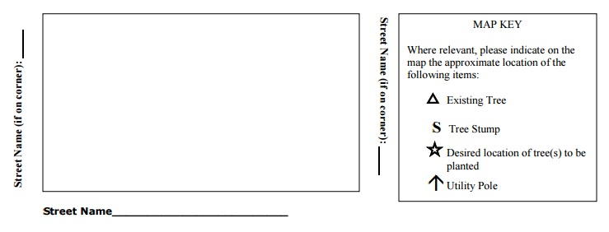
Tree Maintenance Agreement Conditions - To adopt a tree, you must agree to care for the tree as follows.

- To insure your new tree’s survival, it must be water at least once a week for the first two years during the growing season. (This applies if it is planted on or in front of your property.)
- Mulch should not be piled up against the tree trunk. Keep grass and weeds out of mulch.
- Do not cultivate or otherwise disturb soil under the tree (do not plant under trees.)
- Keep lawn mowers and string trimmers away from tree to avoid wounding trunk.
- Fertilize only with slow release formulas, if at all.
- Do not use herbicides that may leach into the soil around the tree.
- Inspect the tree often to detect problems early.
- All Trees and Shrubs shall be planted and cared for, as stated in Title 9, Chapter 8, Trees and Shrubs (Ord. 390, 9-11-1989) in the City Code.

My signature indicates my agreement to the conditions listed immediately above.

Signature: _____________________________________________ Date:____________________

